Rapidly clicking between different categories I.e., phones, laptops, monitors

Rapidly clicking on phones

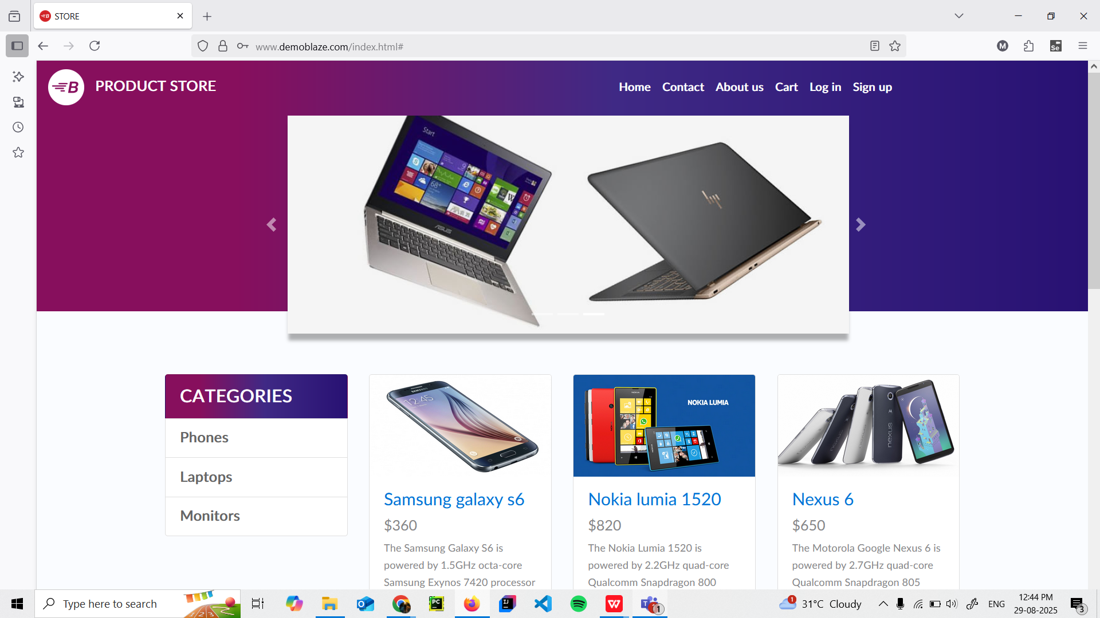

Rapidly clicking on monitors

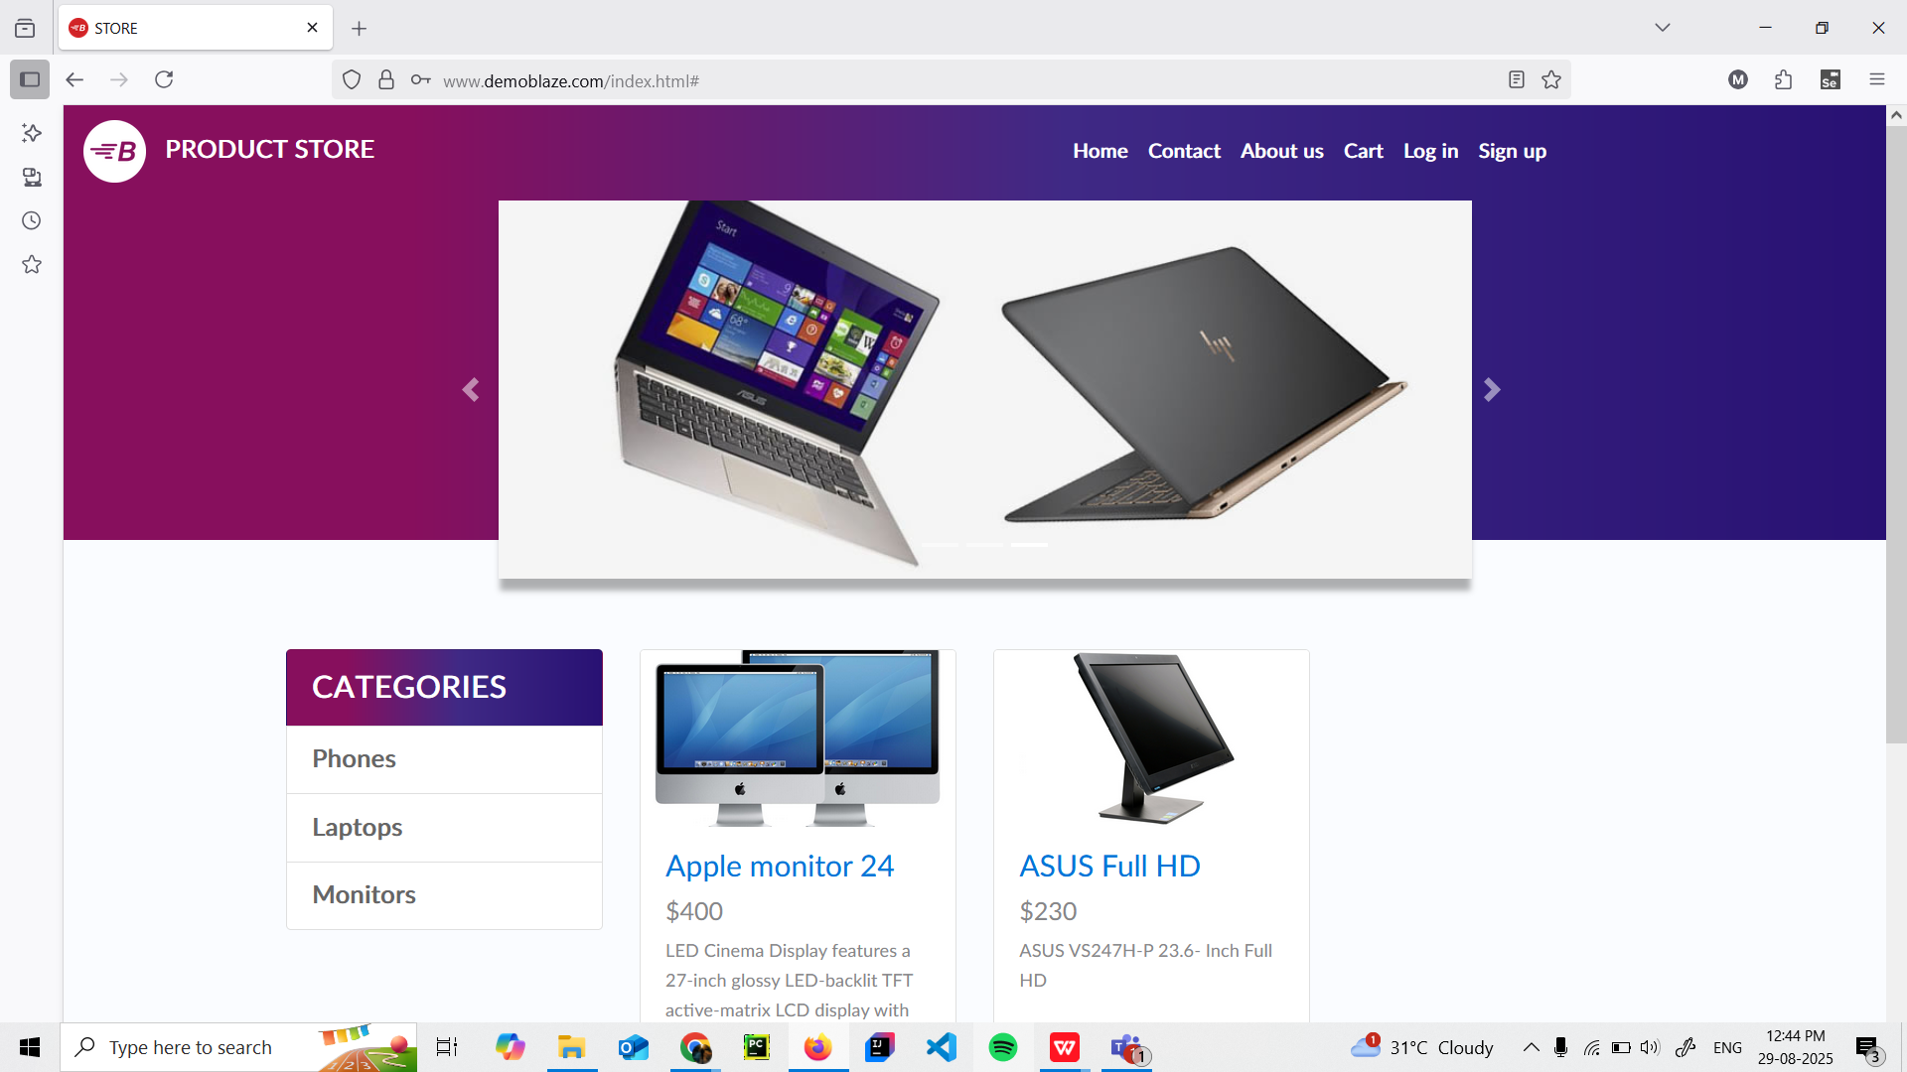

Rapidly clicking on laptops

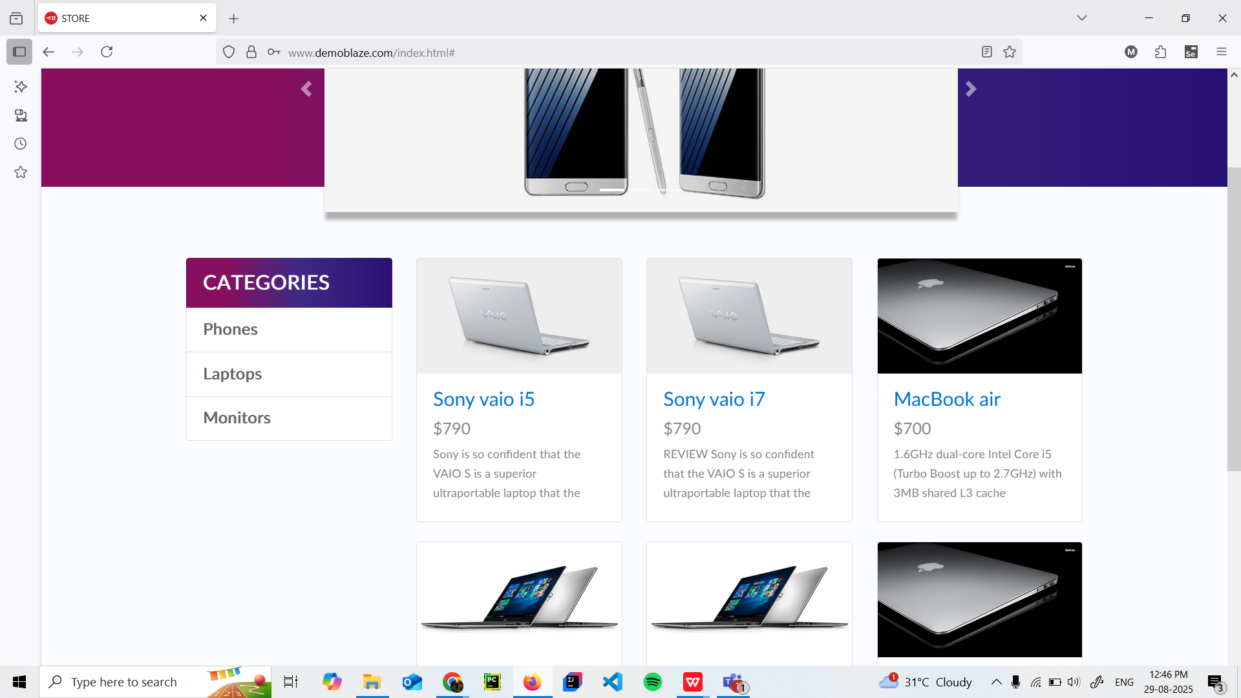

Rapidly clicking on categories

